HOW TO COMPLETE A REQUEST FOR EQUIPMENT APPROVAL IN PVSAS
- LOG IN TO YOUR PVSAS ACCOUNT
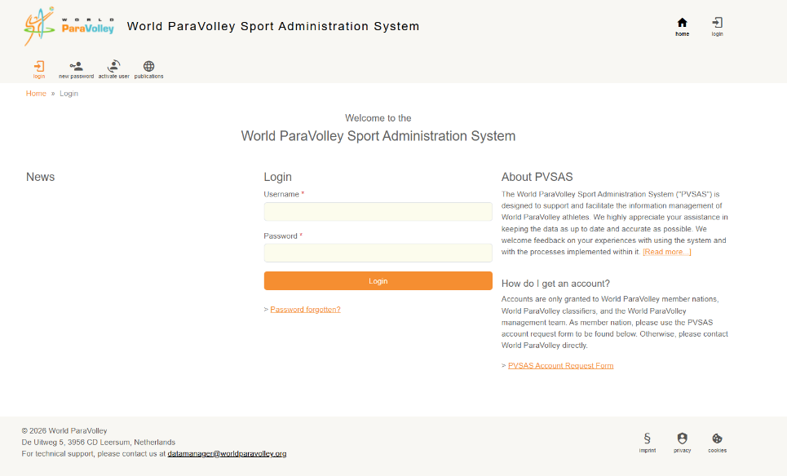

- SELECT ATHLETES TAB
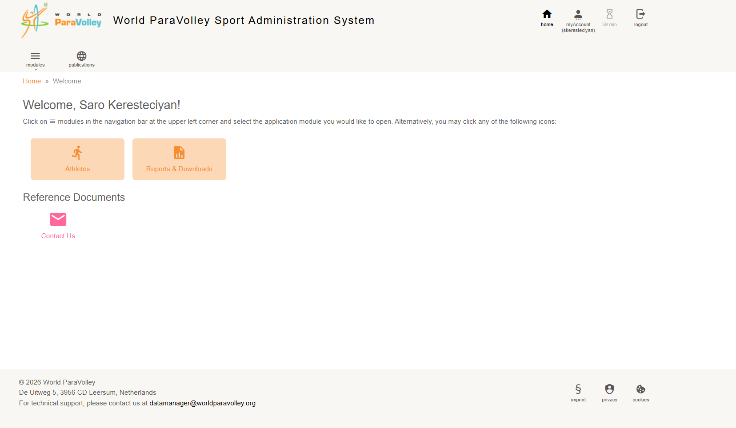

- SELECT ATHLETE CONCERNED (for this example we will use Test Tester)
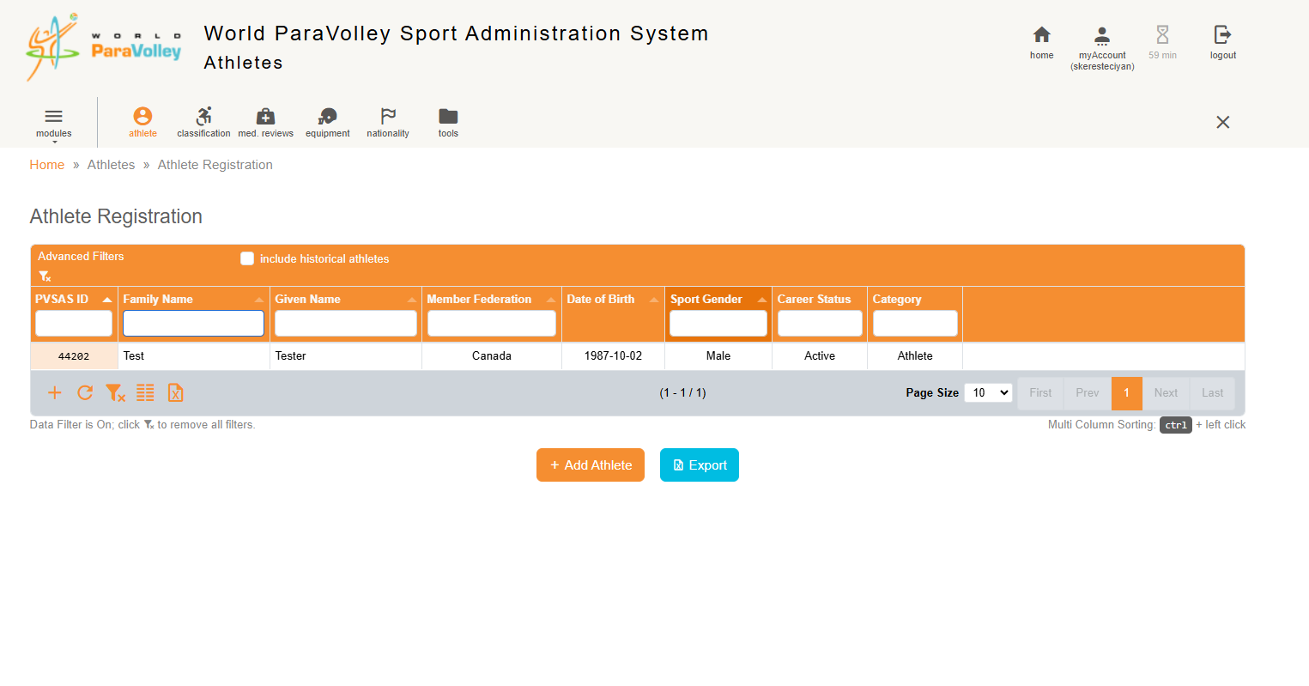

- CLICK ON THE EQUIPMENT TAB (HELMET LOGO ON THE RIGHT SIDE)
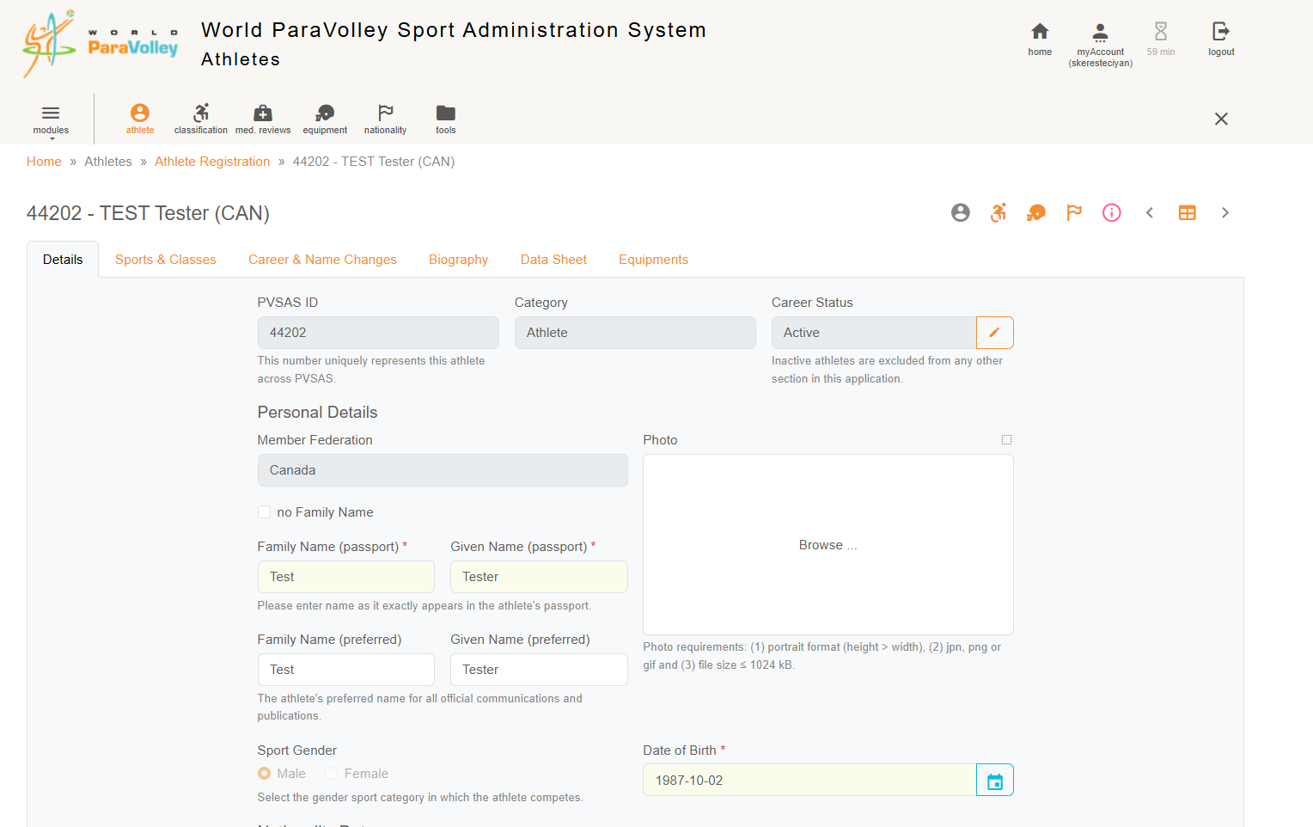

- CLICK ON “NEW EQUIPMENT SET” & FILL IN THE BASIC INFORMATION FIELDS FOR THE EQUIPMENT IN QUESTION (Make sure to hit Save)
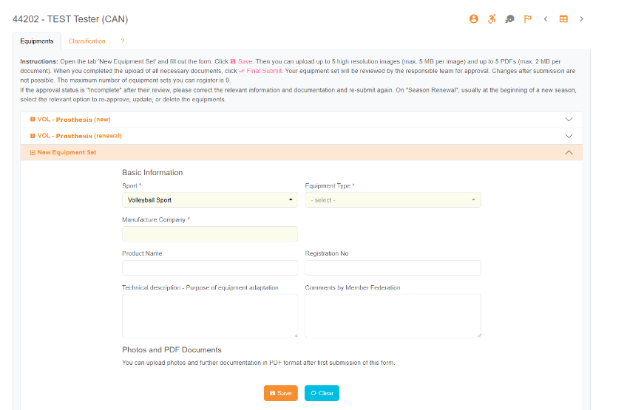
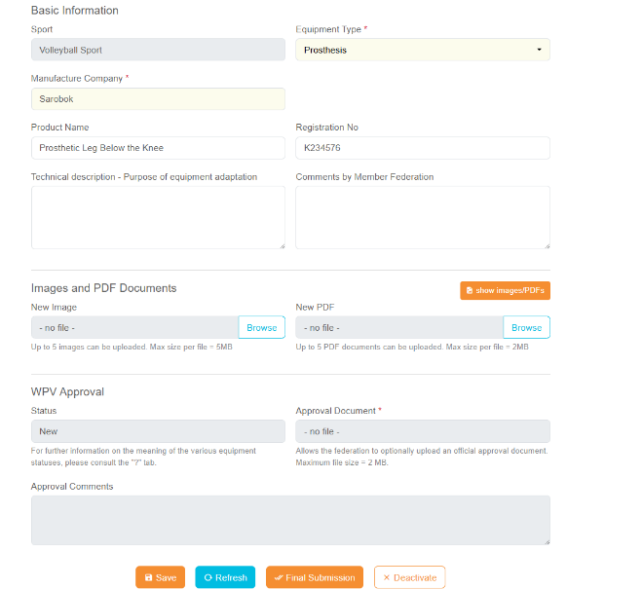

Fill in as much info as possible

Once you hit save, it should look like this

- Once you have saved the information, please open the Adaptive Equipment document (example below. This document will be available on the WPV website. Please fill in all the information and save document to your computer.
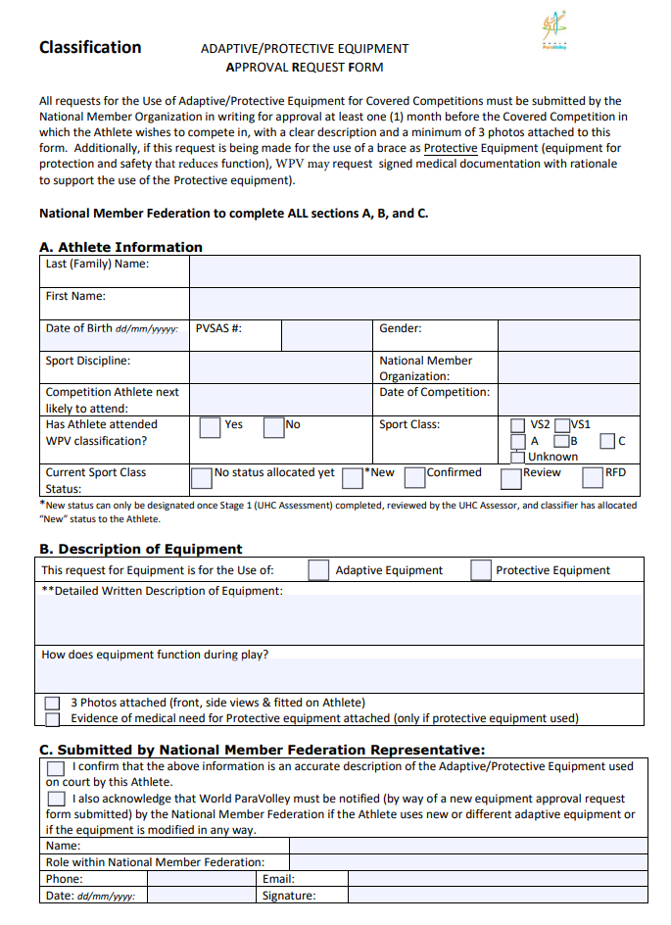

- Once this document is filled out and saved, please upload in PVSAS in the document section.
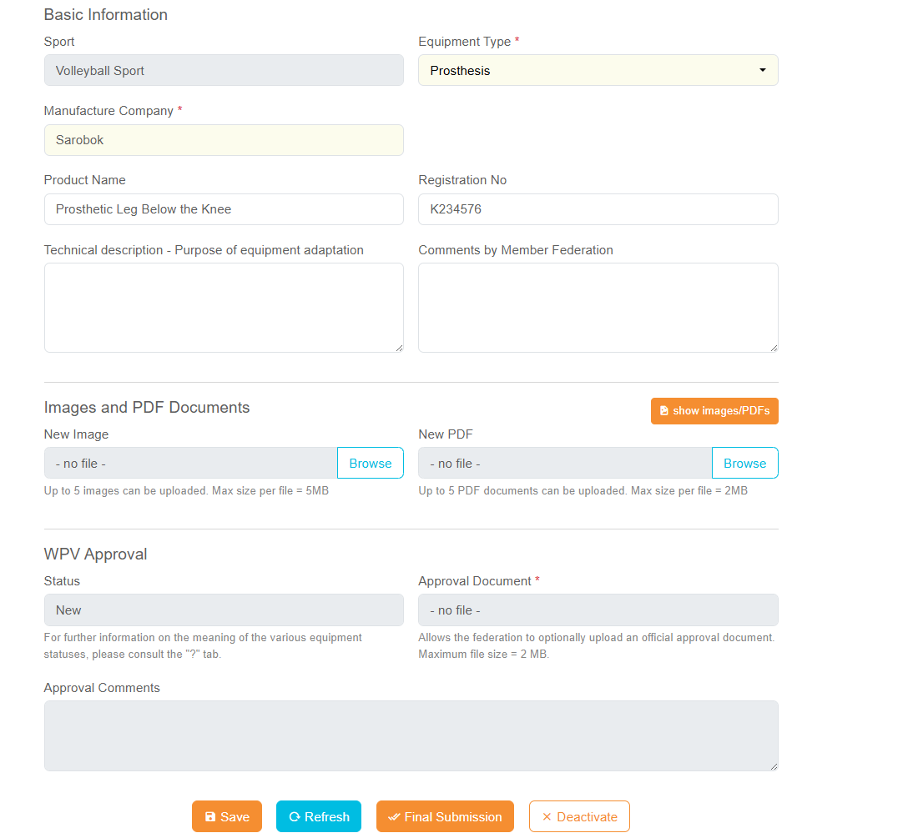

- Please also upload images of the equipment in the appropriate “New Image” section. Photos of adaptive equipment should be completed on a plain white/gray background (mandatory 3 photos: front view, side view, and view of Athlete with equipment in place).

- Once you have saved everything, you should see the new equipment saved on the athlete equipment profile:
