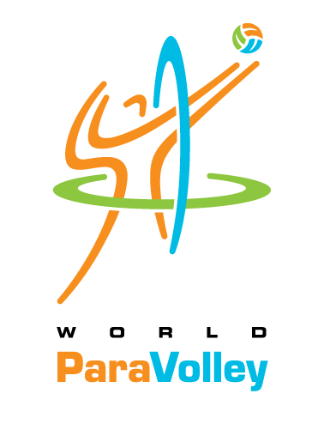
World ParaVolley Technical Official (TD/Jury) Course
Application Form

This form is to be completed by anyone wishing to participate in a World ParaVolley Technical Official Course at any level. Please refer to the WPV International Technical Official Education and Training Pathway, to ensure that you understand what the course involves and it is what you are seeking.

Please be sure to complete all sections fully. Your information and technical qualifications, along with any attachments, will allow the Technical Commission to assess your background. Upon receiving your application form, the Technical Commission will reach out to you to discuss course options that are most appropriate for you.

You should understand that the role of a Jury Member or Technical Delegate carries significant responsibilities, so it is essential that you already have sound knowledge of Volleyball and/or ParaVolley. Experience at international events, while not essential, is an advantage. You must be willing to work with a technical official team and also be willing to commit time to your nation and zone events as required.

Applicant’s Personal Information
FAMILY Name: |  |  | GIVEN Name(s):
Nationality: |  |  | Gender:
Passport #: | Expiry date: |  |  | Place of issue:
Date of Birth: |  | Place of Birth:
Profession:

Contact Information
Address:
Home Phone: |  | Mobile:
E-mail address: |  | WhatsApp number:
Speak and write in English: Yes / No | Languages spoken:

Applicant Information / Technical Qualification
Highest Qualification
Level: |  |  | Year: | Country:
Other Qualification / Experience (please add a second page if necessary)
Year | Location (country) | Qualification / Experience

Attachments – please include the following with this form:
Resume / CV: | Proof of Qualification:  Including statement of  Prior Learning (if applicable) | Statement:  (please outline your Technical Delegate or Jury & ParaVolley experience, career, reason for attending course)

X I hereby confirm that all information provided above is true and correct. I will conform to the Rules & Regulations of the course. I fully understand that my participation is at my own risk in all respects and will not hold World ParaVolley or the LOC responsible for any mishaps, accidents, etc. I agree to ensure the full fees as advertised in the invitation letter are paid, to complete the full duration of the course and to undergo all evaluations conducted.

Participant Signature: Date:

CERTIFICATION / VERIFICATION
(by World ParaVolley Member, NPC, or National Volleyball Federation)

The World ParaVolley Member Nation, NPC or Volleyball Federation supports the above candidate’s application to participate in a World ParaVolley Technical Official Course as per the above.

Official Seal of the WPV Member,
NPC or National VB Federation

Federation Name:

(Signature of Official)
Name:
Function:
Date:

IMPORTANT: Please return the Application Form by e-mail to:
Toralv Thorkildsen, World ParaVolley Technical Commission Chair  Glenn Stewart, Technical Commission Education Coordinator | technical@worldparavolley.org  glenndstewart56@gmail.com

Copy to your respective Zone Sport Director:
PARAVOLLEY AFRICA | PARAVOLLEY EUROPE | PARAVOLLEY ASIA-OCEANIA | PARAVOLLEY PAN-AMERICAN
Mr. Said Lamrini | Mr Zdravko Hranić | Ms Tijanna Bibis | Ms. Cristiana Figueira
Morocco | Croatia | Australia | Brazil
Email:  drsaidlamrini@gmail.com | Email: sports.director@paravolley.eu | Email: tijanna.bibis@gmail.com | Email:  crisfigueira12@gmail.com

