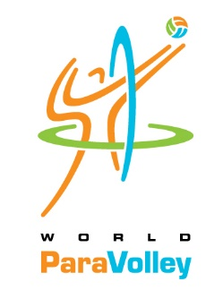
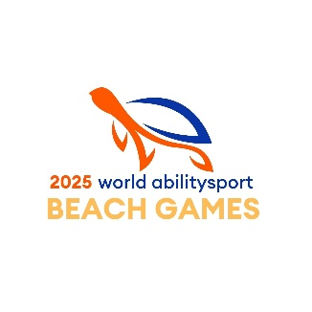
WPV Beach ParaVolley International Referee Course
Level III

This is an International Beach Paravolley referee course to be held in conjunction with the WPV Beach ParaVolley World Championships at the World Ability Sports Beach Games to be held in Mersin, Türkiye. This is the first-ever International Beach Paravolley refereeing course and we wish all of the candidates welcome to this historical happening.

Dates for the course are:

Arrival 18 October 2025
Departure 25 October 2025

About the course:

The course will consist of both Theory and Practical Elements conducted in conjunction with and during the World Championships. There will be 15 hours of Theory followed by a written exam. There will also be four days of Practical Refereeing and assessment.

The course will be conducted in English, so there is a need for a good understanding and use of the language. The level of proficiency in English with be assessed during the course.
The course is aimed at existing beach volleyball referees and will also address all areas involved with the transition to Beach ParaVolley.

Criteria for participation:

To be eligible to register, the following criteria must be met:

Be an active beach volleyball referee, either continental or FIVB-registered.

Submit with your application a record of your activity over the last 2 years.

A letter of support from your home federation, which must be a member in good standing of WPV.

There will be a confederation or zone quota to be observed.

Age limit for this course only will be open to encourage participation.

Completion of the appropriate medical certificate (to be submitted with the course application).

Supporting statement as to why you wish to be involved with the ParaVolley movement
and your aims and objectives for doing so.

Costs:

The costs of the course are as follows:

Course registration fee: 200 Euro
Payment for the course fee is being made directly to World ParaVolley.
Here is the necessary information needed to make payment to WPV:
Beneficiary: Stichting Promotie Volleyball Voor Gehandicapten
Bank Name: Rabobank
Bank Address: Croeselaan 18, 3921 CB Utrecht, Netherlands
IBAN: NL98 RABO 0384 4729 23
Swift code/BIC: RABONL2U

Accommodation and food, local travel in Türkiye: 200 Euro per person per night Single Room
(1400 Euro for 7 days)

150 Euro Per person per night Double Room (1050 Euro for 7 days)
Payment for accommodations, food and local transportation is being made directly to the LOC.
Here is the necessary information needed to make payment:
Bank Name: GARANTI BANKASI A.S.
Bank Address: GAYRETTEPE MAH. YILDIZ POSTA CADDESI NO:52 SISLI, ISTANBUL TURKİYE
ACCOUNT NAME: TURKIYE MILLI PARALIMPIK KOMITESI DERNEGI
ACCOUNT NO: 9086022
SORT CODE: 347
SWIFT CODE: TGBATRIS
IBAN: TR82 0006 2000 3470 0009 0860 22

Travel

Travel to Turkey: At candidates’ expense
Nearest Airport is Cukurova International, Mersin (Code COV)

Applications must be made by the 15th July 2025
Applications to be sent to the following email addresses:
beachparavolley@worldparavolley.org
jeffbrehaut@icloud.com
sportdirector@worldparavolley.org
developmentdirector@worldparavolley.org

WPV Beach ParaVolley International Referee Course
Level III
Application Form

Name | Address | Phone | Email
Federation | Gender | Current Qualification | Age
International Beach Volleyball Course | Date | Instructor | Venue
Activity | Dates | Matches Refereed

This application form must be submitted with:

Letter of support from your National Federation

Medical Verification (M-7) complete and signed

Supporting Statement

Initial Registration fee (non-refundable)

